***BONNE TERRE PREPARATORY SCHOOL***

**Monday 27th April – Thursday 30th April, 2020**

**Learning from home virtual online teaching**

**Materials Needed:**

* **Pencils**
* **Scissors**
* **Crayons**
* **Glue**
* **Assignment Worksheets**
* **Videos**
* **Balloon with holes**
* **Healthy snack ingredients (required for Thursday)**
* **Cotton ball**
* **Straw**
* **tape**

**Day 1 (Monday 27th April, 2020)**

**Community Helpers: Nurse and Doctor**



Good morning to you!

And how do you do?

I am the doctor

Healing people like you!

I am the nurse, helping the doctor help you**.**

Nurses are trained men or women who help us stay healthy. They are trained in health and healing and doctors depend on nurses to help them to do their jobs.

Video will be sent via WhatsApp medium.

**Mathematics**

**Students will begin by watching a video on number 9.**

**https://youtu.be/71px2KDIraE**

**Language Arts**

**Letter Nn**

**Students will begin by singing the ABC (alphabet song).**

**Students will recognize the letter Nn.**

**Student will say the name and the sound out loud.**

**Letter Nn song, Click on the click.**

<https://youtu.be/qE5HEeoVGb0>

**Day 2**

**Wednesday 29th April, 2020**

**Topic: Community Helper (Doctor)**

Place the holes in the balloon, blow it up and twist the end but d not tie it. Draw a face on it using the end that you blow on as the mouth.

Tell the kids that there are germs inside of Mr. Balloon and he is going to remember to cover his mouth as he coughs....then let the air out of the balloon covering the opening with your hand (only a few germs should escape).

Then blow him back up and show them what happens to Mr. Balloons germs when he coughs and forgets to cover his mouth....germs fly all over the room

**Miss Polly (song)**

Miss Polly had a dolly who was sick, sick, sick.

So she called the doctor to come quick, quick, quick.

The doctor came with his bag and his hat,

and he knocked on the door with a rat-a-tat.

He looked at the dolly and he shook his head.

He said, 'Miss Polly, put her straight to bed'.

He wrote on his paper for a pill, pill, pill.

'I'll be back in the morning with my bill, bill, bill!'

**Mathematics**

**Students will begin by watching a video on number 9.**

[**https://youtu.be/71px2KDIraE**](https://youtu.be/71px2KDIraE)

**Begin Worksheet**

**Language Arts**

**Letter Nn**

**Students will begin by singing the ABC (alphabet song).**

**Students will be reviewing letter Nn.**

**Student will say the name and the sound out loud.**

**Letter Nn song, Click on the click.**

[**https://youtu.be/HHEqOLZ0hr4**](https://youtu.be/HHEqOLZ0hr4)

**Begin the letter Nn Worksheet.**

**Day 3**

**Thursday 30th April, 2020**

**Topic: Community Helpers: Nurse and Doctor Revision.**

Doctorhelp heal us when we are ill**.** A nurse helps the doctor help you to feel better and they help us stay healthy**.**

Song: Five little monkeys jumping on the bed,

One fell off and bumped his head.

Mama called the doctor and the doctor said,

"NO MORE MONKEYS JUMPING ON THE BED!"

Continue 4, 3, 2, and then

One little monkey jumping on the bed.

She fell off and bumped her head.

Mama called the doctor and the doctor said,

"There are NO MORE MONKEYS JUMPING ON THE BED"

Healthy Snack Preparation: students will prepare a healthy snack of their choice. Photos / video should be sent via WhatsApp.

Video: Nurse

**Physical Education**

Jumping jacks (5)

Frog hops (7)

**Cotton Ball Race**

Provide cotton balls and straws. Tape a START line at one end of the room and a FINISH line at the other end.

The children use the straws to blow the cotton balls to the other end of the room.

**Craft: Doctor Bag**

**Colour, cut and paste**

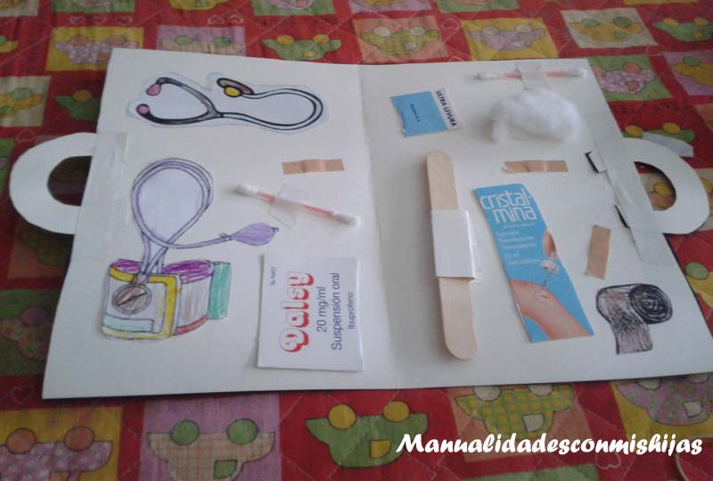

Hope you had a fun week of learning.

Worksheets to be completed for the week:

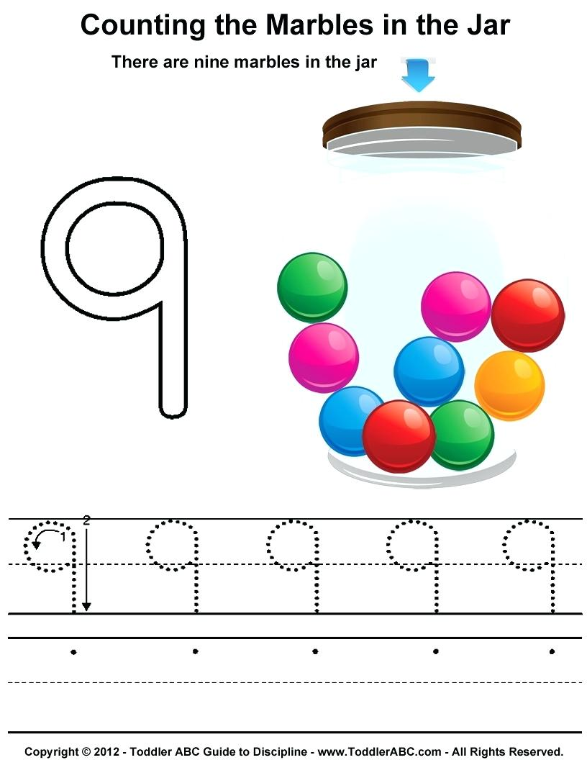

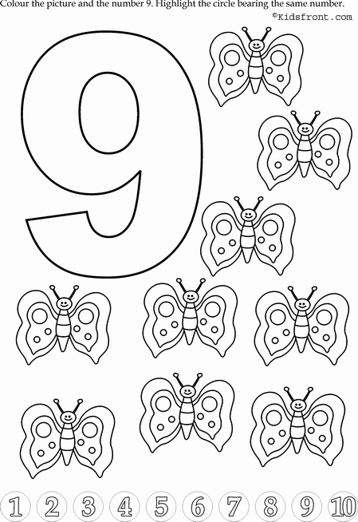Colour the picture. Colour the circle with number 9.

Colour the picture 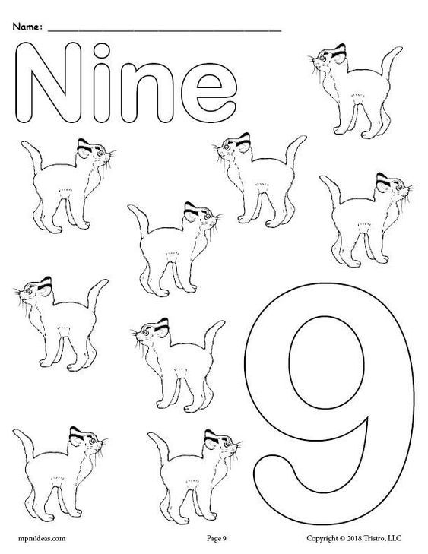

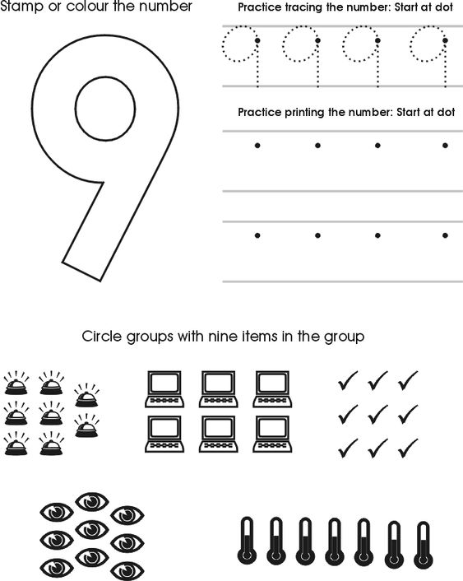

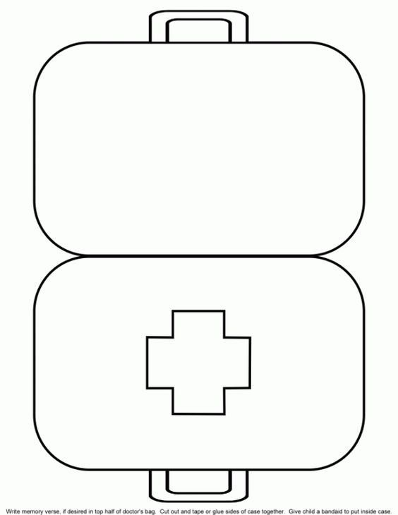Craft: Doctor’s medical bag

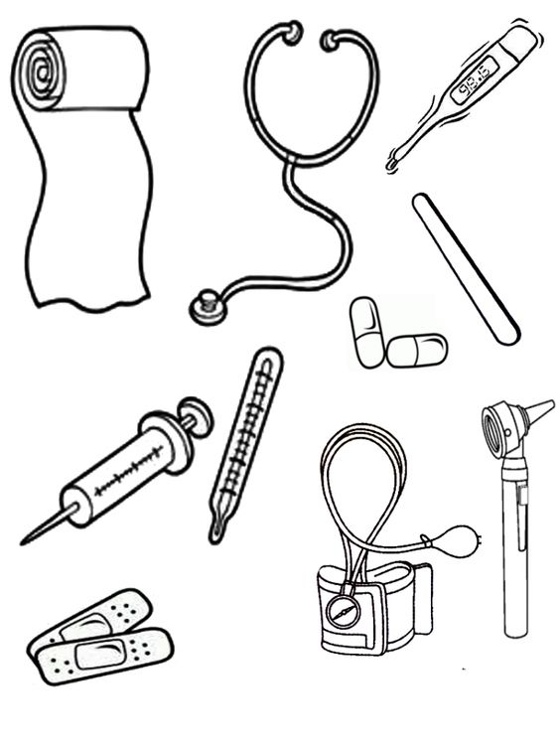

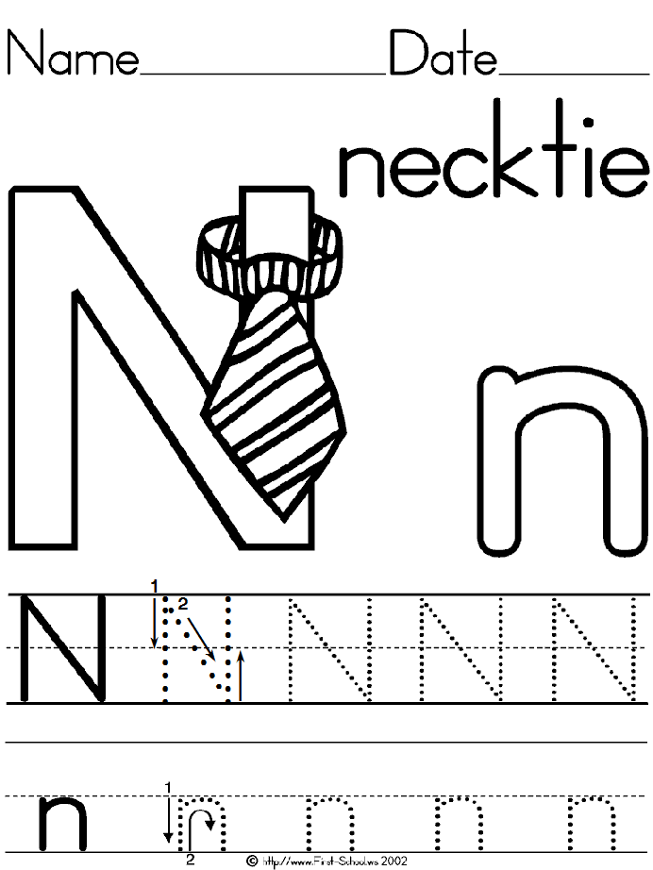Trace and colour

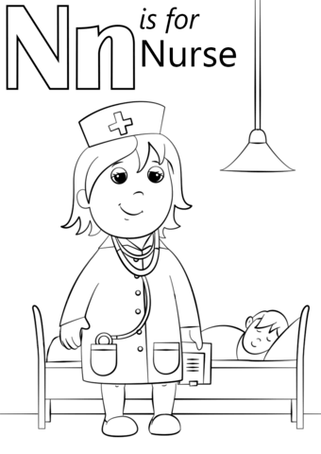Colouring worksheet

